 | 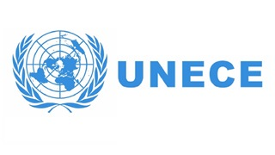 | 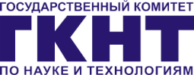

PRESS RELEASE 18 July 2017

The results of the 2nd Innovation Review of Belarus presented in Minsk

The findings and recommendations of the 2nd Innovation Review of Belarus were discussed in Minsk. The Review has been developed jointly by the United Nations Economic Commission for Europe and the State Committee for Science and Technology of the Republic of Belarus.

The State Committee for Science and Technology of the Republic of Belarus and the United Nations Economic Commission for Europe have presented the results of the 2nd Innovation Review of Belarus entitled “Innovation for Sustainable Development”. The first Review was implemented in 2010 and published in 2011. The aim of current Review is to independently assess the progress of Belarus’ innovation sphere over the past period and its current state, and also to develop recommendations for further improving the national policy to stimulate innovation activities, improve innovation capacity and rise the effectiveness of the national innovation system taking into account the UN sustainable development goals.
This Review has been prepared with a deep understanding of the problems of Belarus in innovative development. It notes the country’s achievements in such the spheres as legislative regulation of commercialization of intellectual property, centralization of sectoral innovation funds, long-term and strategic innovation planning, improvement of innovation statistics and methods of collecting data, the preservation of human resources for the innovative development, the development of the information and communication technologies, as well as support for international cooperation. As Belarus is participating in the implementation of the UN Agenda for Sustainable Development until 2030, it was of particular importance to include the innovation-related issues in the National Strategy for Sustainable Development of the Republic of Belarus until 2030.
At the same time the 2nd Review has confirmed that there are a number of problems in the innovation sphere, such as low financing of science and innovations; non-acceptance of risk as an integral element of innovation activities; insufficient involvement of business, particularly SMEs, in innovation activities; predominance of vertical mechanisms of state regulation; and insufficient development of horizontal schemes for coordinating innovative processes in the country.
The results of the Survey generally show that Belarus has managed to neutralize the negative consequences of the crisis of 2011-2012 as well as the subsequent recession. A comparison of the main statistical indicators of innovation activities for 2011 and 2016 demonstrates that during this period the country has succeeded to keep them mainly at the pre-crisis level. For instance, in 2016 the share of exports of high-tech and science-intensive products in the total volume of Belarusian exports, one of the main indicators of innovation performance, increased by 2.3% in comparison with 2015 and amounted to 33.2%. This success was ensured mainly by the increase of the export of such high-tech science-intensive services as the computer services.
The findings and recommendations of the 2nd Review will be used by the State Committee for Science and Technology of the Republic of Belarus and other governmental bodies for developing and implementing the national innovation policy.
Russian version of the Review Summary is available on: http://www.scienceportal.org.by/news/b1336503287c26e1.html.
For further information, please, contact: Olga MEEROVSKAYA, BelISA, +375 17 2033139, meerovskaya@fp7-nip.org.by

