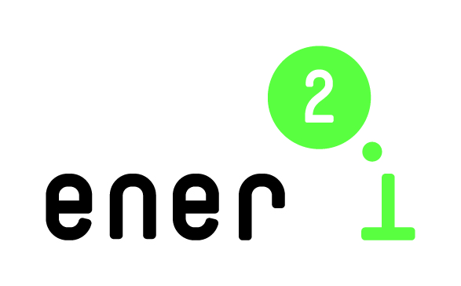 |  | 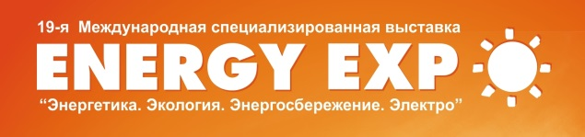

ener2i – energy research to innovation:
Reinforcing cooperation with Eastern Partnership countries on bridging the gap between energy research and energy innovation

ener2i Brokerage Event in Belarus
DRAFT AGENDA

Date: October 14, 2014

Venue: Energy Expo – 2014, Roofed Soccer Arena, Conference Room 2

20/2 Pobediteley ave., Minsk Belarus

09:30 – 10.00 | Registration and handing of individual schedules for face-to-face meetings
10:00 – 10:20 | Welcome and presentation of ener2i activities  State Committee on Science and Technology of Belarus (TBC)  Manfred Spiesberger, Centre for Social Innovation, Austria  Olga Meerovskaya, Belarusian Institute of System Analysis and Information Support of Scientific and Technical Sphere
10:20 – 11:20 | ener2i Belarus Innovation Voucher Award Ceremony  Results of the Innovation Voucher Competition 2014  Anatoly Hryshnovich/Alla Minko, Belarusian Innovation Fund  Presentations of the projects – winners of the competition (10 min/project)
11:20 – 11:45 | Horizon 2020, EU Programme for Research and Innovation: opportunities for Belarus-EU cooperation in energy efficiency and renewable energy  Olga Meerovskaya, BelISA  At the morning session, simultaneous translation is foreseen.
11:45 – 12:30 | Coffee break
12:30 – 14:00 | Bilateral face-to-face meetings  Brokering contacts and developing of joint innovative projects, among research and business representatives from Belarus and EU countries  During the bi-lateral meetings, assistance with the translation will be provided, if needed.
ednesday, 15 October 2013 – Energy Congress

